**Health Insurance**

Application Form

**Important Information**

Kindly complete the questions on this form in BLOCK CAPITALS and tick the relevant boxes. It is important that you provide the following information accurately so that we can process your application accordingly. This application must be completed in the Policy Holder or Insured Member’s own handwriting (over 18 years old). If you need to make a correction, please highlight the change and add the date on it. For full details of the policy’s terms and conditions, please refer to the table of benefits and membership handbook, available from AXA representative upon your request. We look forward to welcoming you as a member of AXA Insurance (Gulf) B.S.C. (c).

*If you have any questions when completing this form, please contact your AXA sales team representative.

**Important information about your membership declaration**

* It is essential that you provide the complete information before you sign on your medical application form and your medical health declaration.
* This form must be received by AXA Gulf within (30 days) from the declaration date. If we receive this form after 30 days from the signed declaration date, or with incomplete information, we will not be able to register your details and enrol you into the Health Insurance plan.
* It is advisable that you fill in your form with an up to date medical history before you sign and date this form.  Claims will not be payable if you do not fully disclose any facts which could influence our assessment of this application and if you are in any doubt as to whether any facts, you should disclose them.  You are advised to keep a record of all information you disclose to us in connection with this application, including letters
* Medical information will be kept confidential. Personal data collected from you and your family will be used by AXA Gulf to process your claims, administer your policy and may be used to detect and prevent fraud or improper claims. It will only be disclosed to those involved with your treatment or care and, if applicable, to any person or organisation who may be responsible for meeting your treatment expenses.
* All membership documents and confirmation of how we deal with any claim you may make will be sent to the principal member.
* In the interest of continuously improving our service; your calls will be recorded and may be monitored.  Prior to signing the application, please make sure that you have read, understood and agreed to the policy terms and conditions.

First name:

Middle name:

Last name:

Gender:

M

F

Date of birth:

DD/MM/YYYY

P.O. Box:

Marital status:

Single

Married

Divorced

Widow

Address:

**Policy holder details**

(

please keep us informed of any change in your address

)

|  |  |
| --- | --- |
| Email: | Passport number: |
| Telephone number: Country Code Area code Number | Mobile number: Country Code Area code Number |
| Occupation: | Salary band: Less than AED 4,000 More than AED 4,000 |
| Name of company (Employer): | Nationality: |
| National ID number: | Place of visa issuance: |

VISA UID Number:

Do you have any health insurance currently in UAE, or have you received any health Insurance quotation recently?

Yes

No

**Existing or previous medical insurance**

|  |  |  |  |
| --- | --- | --- | --- |
| AXA Gulf | Policy/quote number: | Policy expiry date: | DD/MM/YYYY |
| Other insurers | Policy/quote number: | Policy expiry date: | DD/MM/YYYY |

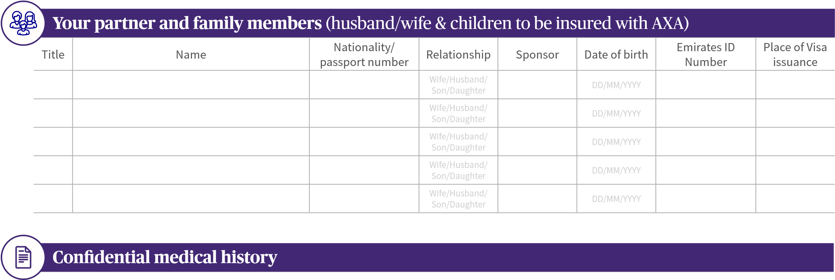

Declarations must be made in writing on this application. Verbal declarations are not acceptable.This section requests your health and medical history details, past and present, including each family member named in the section above. Please tick Yes or No to every single question for every person included in this application. If you tick Yes to a question, please provide full details in the following section. Please ensure you declare any known or suspected condition, and any discomfort or symptoms experienced before your policy starts, even if professional advice has not yet been sought. Any declared condition shall be covered under the pre-existing limit as per the plan terms and conditions. Please note that AXA reserves the right to decline your claim and not pay it, if you do not provide us with full details of any existing medical condition.

|  |  |  |  |  |  |  |
| --- | --- | --- | --- | --- | --- | --- |
| **Section A: Please answer all questions below and if any of them is answered with “yes”, provide details in section B:** | | | | | | |
|  | Principal | Dependant 1 | Dependant 2 | Dependant 3 | Dependant 4 | Dependant 5 |
| Name |  |  |  |  |  |  |
| Height (cm) |  |  |  |  |  |  |
| Weight (kg) |  |  |  |  |  |  |
| Do you smoke? | Yes No | Yes No | Yes No | Yes No | Yes No | Yes No |
| 1. Are you under any medical supervision, undergoing any medical/surgical treatment, was advised for the same or have been admitted to the hospital in the last five years? | Yes No | Yes No | Yes No | Yes No | Yes No | Yes No |
| 2. Do you have any chronic or pre-existing medical condition*? | Yes No | Yes No | Yes No | Yes No | Yes No | Yes No |
| 3. Are you taking any medication or have been advised to take for a period more than seven days? | Yes No | Yes No | Yes No | Yes No | Yes No | Yes No |
| 4. Do you have any bone, joint or spine disease/complaints? | Yes No | Yes No | Yes No | Yes No | Yes No | Yes No |
| 5. Have you been diagnosed, investigated or treated for any type of tumor, lump or cancer? | Yes No | Yes No | Yes No | Yes No | Yes No | Yes No |
| 6. Do you have/had a medical condition which is not listed in the questions above (excluding cold or flu, vaccination, normal checkups without medical condition or symptoms). | Yes No | Yes No | Yes No | Yes No | Yes No | Yes No |
| 7. **For females only:**  a. Are you currently pregnant? | Yes No | Yes No | Yes No | Yes No | Yes No | Yes No |
| b. If you answered yes on the above question, have you faced any complications up to date? | Yes No | Yes No | Yes No | Yes No | Yes No | Yes No |
| c. Provide the date of your last menstrual period. | DD/MM/YYYY | DD/MM/YYYY | DD/MM/YYYY | DD/MM/YYYY | DD/MM/YYYY | DD/MM/YYYY |
| d. Are you currently trying to get pregnant or undergoing any form of fertility treatment? | Yes No | Yes No | Yes No | Yes No | Yes No | Yes No |

**Section B. Please provide details of all questions answered yes in the previous section:**

*Chronic illness: a condition with one or more of the following criteria: last 3 months or more, leaves residual disability, is caused by non-reversible pathological alteration, requires special training of the patient for rehabilitation, or may require long period of supervision or observation, e.g. diabetes mellitus, hypertension, coronary artery disease etc.

*Pre-existing condition: an illness or health condition that was known and existed prior to submitting the application.

**Your membership declaration**

I hereby apply to be insured into the AXA Health Insurance program together with my family members listed above. I declare to the best of my knowledge and belief that the disclosed information given on this application form is complete, true and correct. I understand and acknowledge any pregnancy not declared at the time of this application’s coverage will be at the sole discretion of the insurer. The insurer has the right to not cover any maternity claims to any undeclared pregnancy. I also acknowledge and understand any pregnancy, which arises within forty calendar days from the date of this application; coverage will also be at the discretion of the insurer. I am the undersigned and I confirm that I have received and read the terms and conditions of this policy, read and understood the table of benefits, list of exclusions and the full terms and conditions of the opted for Health plan. I agree that AXA Gulf rules and internal guidelines would apply to me and to the eligible dependents included in my membership.

I understand that any change on my plan benefits which upgrades or downgrades my Health Insurance plan would only be possible at the time of renewal subject to AXA Gulf’s acceptance, the completion of a new application form in addition to any other forms or reports that may be requested by AXA Gulf. I understand and give explicit consent that any sensitive health and other information I may provide about myself will be used, stored, transferred and/or disclosed by AXA, its agents, associated companies, other insurers, regulators, industry and public bodies (including the police) and agencies to process this insurance and any other insurance, to handle claims and prevent fraud which may involve the transfer of such information to other countries.

AXA has taken steps to ensure that your information is held securely. You have the right to access your personal data held by AXA. If you believe that your personal data held by AXA is inaccurate you have the right to ask for this to be rectified.

Signature: Date: DD/MM/YYYY

AXA Insurance (Gulf) B.S.C. (c)

Registered in the Insurance Companies Register - Certificate No. (69) - dated 22/01/ 2002. Subject to the provisions of Federal Law No. (6) of 2007 concerning the establishment of Insurance Authority and Organization of its work. Agents: Kanoo Group